Reaction rate and Reversible reaction.

Factors affecting rate of reaction.

Factors affecting rate of reaction.

There are five factors that affect the rate (speed) of a chemical reaction:

* Temperature
* Concentration
* Particle size
* Use of catalyst
* Pressure

Concentration

Effect of concentration on the Rate of Reaction:

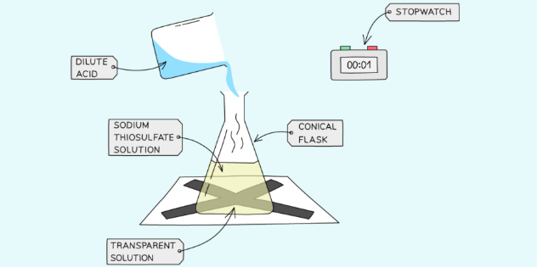

**Procedure**

* Measure 50 cm3 of Sodium Thiosulfate solution into a flask.
* Measure 5 cm3 of dilute Hydrochloric acid into a measuring cylinder.
* Draw a cross on a piece of paper and put it underneath the flask.
* Add the acid into the flask and immediately start the stopwatch.
* Look down at the cross from above and stop the stopwatch when the cross can no longer be seen.
* Repeat using different concentrations of Sodium Thiosulfate solution (mix different volumes of sodium thiosulfate solution with water to dilute it).

**Discussion & Results**

* The reaction between sodium thiosulphate and hydrochloric acid forms a yellow precipitate of sulphur.



* As more and more sulphur is formed, the cross becomes less and less visible until it disappears.
* The time taken for the cross to be invisible is shorter at higher concentration. Therefore the reaction is faster at higher concentration.
* This is because there will be more reactant particles in a given volume, allowing more frequent and successful collisions, increasing the rate of reaction.

**Graphical analysis**

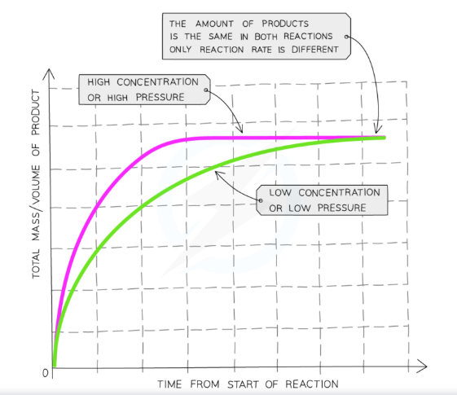

**Graph showing the effect of concentration on the rate of reaction**

* Compared to a reaction with a reactant at a low concentration, the graph line for the same reaction but at a higher concentration has a steeper gradient at the start and becomes horizontal sooner.
* **This shows that with increased concentration of a solution, the rate of reaction will increase.**

Temperature

Effect of temperature on the Rate of Reaction:

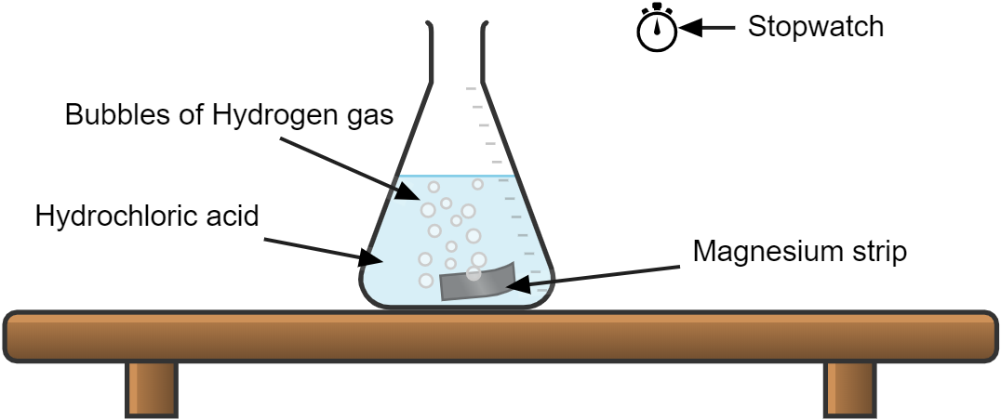

**Procedure**

* Dilute Hydrochloric acid is heated to a set temperature using a water bath.
* Add the dilute Hydrochloric acid into a conical flask.
* Add a strip of Magnesium and start the stopwatch.
* Stop the time when the Magnesium fully dissolves.
* Repeat at different temperatures and compare results.

**Discussion & Results**

* The rate of reaction is measured by how fast the mass of magnesium decreases. In other words, the time taken for the piece of magnesium ribbon to disappear.
* The time taken for the magnesium ribbon to disappear is shorter at higher temperature. Therefore the reaction is faster at higher temperature.
* This is because the particles will have more kinetic energy than the required activation energy, therefore more frequent and successful collisions will occur, increasing the rate of reaction.

**Graphical analysis**

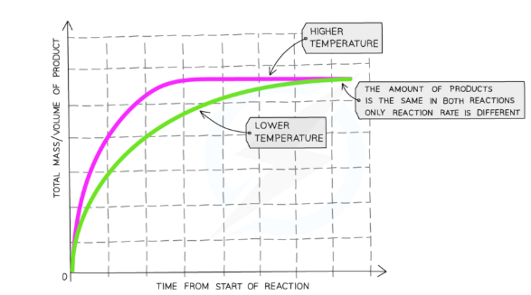

**Graph showing the effect of temperature on the rate of reaction**

* Compared to a reaction at a low temperature, the graph line for the same reaction but at a higher temperature has a steeper gradient at the start and becomes horizontal sooner.
* **This shows that with increased temperature, the rate of reaction will increase.**

Particle size

Effect of Surface Area (particle size) of a Solid on the Rate of Reaction:

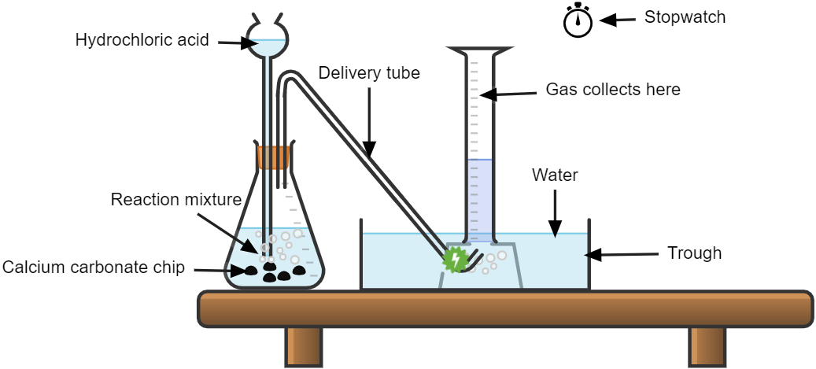

**Procedure**

* Add dilute hydrochloric acid into a conical flask.
* Use a capillary tube to connect this flask to a measuring cylinder upside down in a trough of water (Overwater method)
* Add calcium carbonate chips into the conical flask and close the bung.
* Measure the volume of gas produced in a fixed time using the measuring cylinder.
* Repeat with different sizes of calcium carbonate chips (solid, crushed and powdered).

**Discussion & Results**

* Smaller sizes of chips causes an increase in the surface area of the solid, so the rate of reaction will increase.
* This is because more surface area of the particles will be exposed to the other reactant so there will be more frequent and successful collisions, increasing the rate of reaction.

**Graphical analysis**

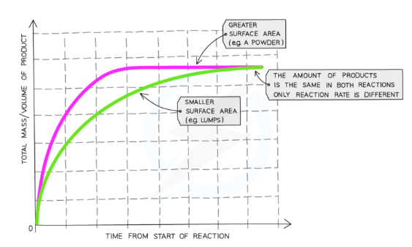

**Graph showing the effect of the surface area of a solid on the rate of reaction**

* Compared to a reaction with lumps of reactant, the graph line for the same reaction but with powdered reactant has a steeper gradient at the start and becomes horizontal sooner
* **This shows that with increased surface area of the solid, the rate of reaction will increase.**

Catalyst

Effect of use of a catalyst on the Rate of Reaction:

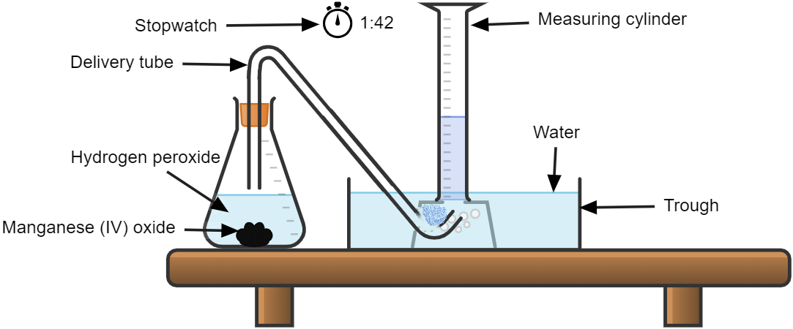

**Procedure**

* Add Hydrogen Peroxide into a conical flask.
* Use a capillary tube to connect this flask to a measuring cylinder upside down in a bucket of water (downwards displacement).
* Add the catalyst Manganese (IV) Oxide into the conical flask and close the bung.
* Measure the volume of gas produced in a fixed time using the measuring cylinder.
* Repeat experiment without the catalyst of Manganese (IV) Oxide and compare results.

**Discussion & Results**

* A substance which alters the rate of a chemical reaction but remain chemically unchanged at the end of the reaction is called a **catalyst.** Manganese (VI) oxide is a catalyst for this reaction.
* Using a catalyst will increase the rate of reaction.
* A catalyst works by **lowering the activation energy** of the reaction. Thus it provide a shorter route for reaction, minimising the energy required for the reaction to proceed.
* This will allow more frequent and successful collisions, increasing the rate of reaction.

**Graphical analysis**

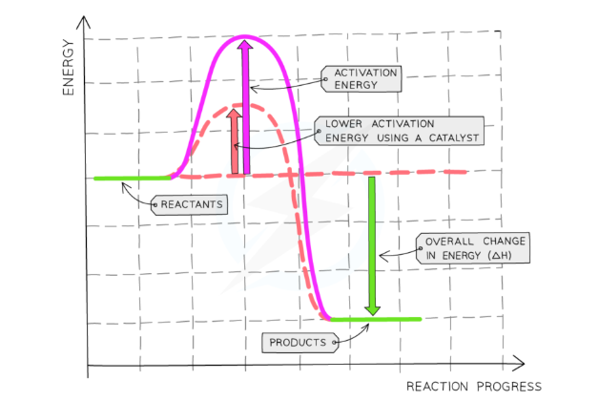

**Graph showing the effect of use of a catalyst on the rate of reaction**

* The diagram shows that when a catalyst is used, the activation energy is reduced as it creates an alternative pathway requiring lower activation energy, allowing more successful and frequent collisions.
* **This shows that when a catalyst is used, the rate of reaction will increase.**

Pressure

* Pressure has no effect on reaction involving solids and liquids. It only affects reaction in which either the reactant or products are gases.
* Increasing the pressure of reacting gases by compressing brings the gaseous particles closer thus increasing the rate of effective collisions.
* **This result in an increase in rate of reaction.**

Photochemical reaction.

* These reactions occur only when light is present.
* The greater the intensity of ultraviolet light then the greater the rate of reaction.

Photography

Photographic film are usually coated with silver bromide. When exposed to light they decompose to silver.

2AgBr(s) → 2Ag (s) + Br2 (g)

Reaction between chlorine and hydrogen

Under normal condition of pressure and temperature, chlorine and hydrogen do not react in darkness. But in the presence of light the reaction takes place rapidly.

H2 (g) + Cl2 (l) → 2HCl (g)

Reaction between Bromine and methane (Bromination)

Under normal condition of pressure and temperature, bromine and methane do not react in darkness. But in the presence of light the reaction takes place rapidly.

CH4 (g) + Br2 (l) → CH3Br (aq) + HBr (g)

Photosynthesis

This is the process in which plants produce food for reproduction and growth. The equation is:

6CO2 (g) + 6H2O (l) → C6H12O6 (aq) + 6O2 (g)